THE 4-HOUR WORK WEEK BY TIM FERRIS | BOOK SUMMARY
The 4-Hour Work Week teaches techniques to increase your time and financial freedom giving you more lifestyle options. By automating a passive income and liberating yourself from unproductive tasks you can live the lifestyle of the ‘new rich’ - one defined by having, doing and being what you want. The author, Tim Ferriss. is an absolute genius and someone every entrepreneur or internet marketer should look upto.

First and Foremost

My Story and Why You Need This Book
Much of what I recommend will seem impossible and even offensive to basic common sense—I expect that. Resolve now to test the concepts as an exercise in lateral thinking. If you try it, you’ll see just how deep the rabbit hole goes, and you won’t ever go back.
Here is the step-by-step process you’ll use to reinvent yourself:
- D for Definition turns misguided common sense upside down and introduces the rules and objectives of the new game.
- E for Elimination kills the obsolete notion of time management once and for all.
- A for Automation puts cash flow on autopilot using geographic arbitrage, outsourcing, and rules of nondecision.
- L for Liberation is the mobile manifesto for the globally inclined.

Step I: D is for Definition
"Reality is merely an illusion,albeit a very persistent one." — Albert Einstein
- Cautions and Comparisons: Howto Burn $1,000,000 a Night
Money is multiplied in practical value depending on the number of W’s you control in your life: what you do, when you do it, where you do it, and with whom you do it. I call this the “freedom multiplier.
Options—the ability to choose—is real power. This book is all about how to see and create those options with the least effort and cost. It just so happens, paradoxically, that you can make more money—a lot more money—by doing half of what you are doing now.
- Rules That Change the Rules: Everything Popular Is Wrong
The following rules are the fundamental differentiators to keep in mind throughout this book.
- Retirement Is Worst-Case-Scenario Insurance. Retirement planning is like life insurance. It should be viewed as nothing more than a hedge against the absolute worst-case scenario: in this case, becoming physically incapable of working and needing a reservoir of capital to survive.
- Interest and Energy Are Cyclical. Alternating periods of activity and rest is necessary to survive, let alone thrive. Capacity, interest, and mental endurance all wax and wane. Plan accordingly. The NR aims to distribute “miniretirements” throughout life instead of hoarding the recovery and enjoyment for the fool’s gold of retirement. By working only when you are most effective, life is both more productive and more enjoyable.
- Less Is Not Laziness. Doing less meaningless work, so that you can focus on things of greater personal importance, is NOT laziness. This is hard for most to accept, because our culture tends to reward personal sacrifice instead of personal productivity.
- The Timing is Never Right. For all of the most important things, the timing always sucks. Waiting for a good time to quit your job? The stars will never align and the traffic lights of life will never all be green at the same time. The universe doesn’t conspire against you, but it doesn’t go out of its way to line up all the pins either.
- Ask for Forgiveness, Not Permission. If it isn’t going to devastate those around you, try it and then justify it. People—whether parents, partners, or bosses—deny things on an emotional basis that they can learn to accept after the fact. If the potential damage is moderate or in any way reversible, don’t give people the chance to say no.
- Emphasize Strengths, Don’t Fix Weaknesses. It is far more lucrative and fun to leverage your strengths instead of attempting to fix all the chinks in your armor. The choice is between multiplication of results using strengths or incremental improvement fixing weaknesses that will, at best, become
mediocre.
- Things in Excess Become Their Opposite. Too much, too many, and too often of what you want becomes what you don’t want. This is true of possessions and even time.
- Money Alone Is Not the Solution. There is much to be said forthe power of money as currency (I’m a fan myself), but adding more of it just isn’t the answer as often as we’d like to think.
- Relative Income Is More Important Than Absolute Income. Relative income uses two variables: the dollar and time, usually hours.
10. Distress Is Bad, Eustress Is Good. Distress refers to harmful stimuli that make you weaker, less confident, and less able. Destructive criticism, abusive bosses, and smashing yourface on a curb are examples of this. Eustress, is positive. Role models who push us to exceed our limits, physical trainingthat removes our spare tires, and risks that expand our sphere of comfortable action are all examples of eustress—stress that is healthful and the stimulus for growth.
- Dodging Bullets: Fear-Setting and Escaping Paralysis
Fearcomes in many forms, and we usually don’t call it by its four-letter name. Fear itself is quite fear-inducing. Most intelligent people in the world dress it up as something else: optimistic denial. Most who avoid quittingtheir jobs entertain the thought that their course will improve with time or increases in income.
If you are nervous about making the jump or simply putting it off out of fear of the unknown, here is yourantidote:
- Define your nightmare, the absolute worst that could happen if you did what you are considering.
- What steps could you take to repairthe damage or get things back on the upswing, even if temporarily?
- What are the outcomes or benefits, both temporary and permanent, of more probable scenarios?
- If you were fired from your job today, what would you do to get things under financial control?
- What are you putting off out of fear?
- What is it costing you—financially, emotionally, and physically—to postpone action?
- What are you waiting for?
- System Reset: Being Unreasonable and Unambiguous
Dreamlining is so named because it applies timelines to what most would consider dreams. It is much like goal-setting but differs in several fundamental respects:
- The goals shift from ambiguous wants to defined steps.
- The goals have to be unrealistic to be effective.
- It focuses on activities that will fill the vacuum created when work is removed. Living like a millionaire requires doing interesting things and not just owning enviable things.
Howto create your dreamlike:
- What would you do if there were no way you could fail? If you were 10 times smarter than the rest of the world? Create two timelines—6 months and 12 months—and list up to five things you dream of having, being, and doing in that order.
- Drawing a blank? Then ask yourself: what would you do if you had $100 million in the bank? And, what would make you most excited to wake up in the morning to another day?
- What does “being” entail doing? Convert each “being” into a “doing” to make it actionable. Identify an action that would characterize this state of being or a task that would mean you had achieved it.
- What are the four dreams that would change it all?
- Determine the cost of these dreams and calculate your Target Monthly
Income (TMI) for both timelines. Start thinking of income and expense in terms of monthly cash flow—dollars in and dollars out—instead of grand totals. Calculate yourTarget Monthly Income (TMI) for realizing these dreamlines. I like to further divide this TMI by 30 to get my TDI—Target Daily Income.
- Determine three steps for each of the four dreams in just the 6-month timeline and take the first step now.

Step II: E is for Elimination
“One does not accumulate but eliminate. It is not daily increase but daily decrease. The height of cultivation always runs to simplicity.” - Bruce Lee*
- The End of Time Management: Illusions and Italians
Effectiveness is doing the things that get you closer to your goals. Efficiency is performing a given task (whether important or not) in the most economical manner possible. Being efficient without regard to effectiveness is the default mode of the universe.
Here are two truisms to keep in mind:
- Doing something unimportant well does not make it important.
- Requiring a lot of time does not make a task important.
Pareto’s Law can be summarized as follows: 80% of the outputs result from 20% of the inputs. Alternative ways to phrase this, depending on the context, include:
- 80% of the consequences flow from 20% of the causes.
- 80% of the results come from 20% of the effort and time.
- 80% of company profits come from 20% of the products and customers.
- 80% of all stock market gains are realized by 20% of the investors and 20% of an individual portfolio.
Parkinson’s Law dictates that a task will swell in (perceived) importance and complexity in relation to the time allotted for its completion. It is the magic of the imminent deadline. If I give you 24 hours to complete a project, the time pressure forces you to focus on execution, and you have no choice but to do only the bare essentials. If I give you a week to complete the same task, it’s six days of making a mountain out of a molehill.
This presents a very curious phenomenon. There are two synergistic approaches for increasing productivity that are inversions of each other:
- Limit tasks to the important to shorten work time (80/20).
- Shorten work time to limit tasks to the important (Parkinson’s Law).
The best solution is to use both together: Identify the few critical tasks that contribute most to income and schedule them with very short and clear deadlines.
The key to having more time is doing less:
- If you had a heart attack and had to work two hours per day, what would you do?
- If you had a second heart attack and had to work two hours per week, what would you do?
- If you had a gun to your head and had to stop doing 4/5 of different time- consuming activities, what would you remove?
- What are the top-three activities that I use to fill time to feel as though I’ve been productive?
- Who are the 20% of people who produce 80% of your enjoyment and propel you forward, and which 20% cause 80% of your depression, anger, and second-
guessing?
- Learn to ask, “If this is the only thing I accomplish today, will I be satisfied with my day?
- Put a Post-it on your computer screen or set an Outlook reminder to alert you at least three times daily with the question: Are you inventing things to do to avoid the important?
- Do not multitask.
- Use Parkinson’s Law on a Macro and Micro Level.
- The Low-Information Diet: Cultivating Selective Ignorance
From this point forward, I’m going to propose that you develop an uncanny ability to be selectively ignorant. Ignorance may be bliss, but it is also practical. It is imperative that you learn to ignore or redirect all information and interruptions that are irrelevant, unimportant, or unactionable. Most are all three.
You need to develop and maintain a low-information diet:
- Go on an immediate one-week mediafast.
- Develop the habit of asking yourself, “Will I definitely use this information for something immediate and important?
- Practice the art of nonfinishing.
- Interrupting Interruption and the Art of Refusal
For our purposes, an interruption is anything that prevents the start-to-finish completion of a critical task, and there are three principal offenders:
Time wasters: those things that can be ignored with little or no consequence. Common time wasters include meetings, discussions, phone calls, web surfing, and e-mail that are unimportant.
- Limit e-mail consumption and production. This is the greatest single interruption in the modern world.
- Turn off the audible alert if you have one on Outlook ora similar program and turn off automatic send/receive, which delivers e-mail to your inbox as soon as someone sends them.
- Check e-mail twice perday, once at12:00 noon orjust priorto lunch, and again at 4:00 P.M. 12:00 P.M. and 4:00 P.M. are times that ensure you will have the most responses from previously sent e-mail.
- Screen incoming and limit outgoing phone calls.
- Use two telephone numbers if possible—one office line (non urgent) and one cellular (urgent). This could also be two cell phones, orthe non-urgent line could be an Internet phone numberthat routes calls to online voicemail (www.skype.com, for example).
- If someone does call yourcell phone, it is presumably urgent and should be treated as such. Do not allow them to consume time otherwise.
- Decide that, given the non-urgent nature of most issues, you will steer people toward the following means of communication, in order of preference: e-mail, phone, and in-person meetings.
- Respond to voicemail via e-mail whenever possible. This trains people to be concise. Help them develop the habit.
- Meetings should only be held to make decisions about a predefined situation, not to define the problem.
- If you absolutely cannot stop a meeting or call from happening, define the end time.
Time consumers: repetitive tasks or requests that need to be completed but often interrupt high-level work. Here are a few you might know intimately: reading and respondingto e-mail, making and returning phone calls, customer service (order status, product assistance, etc.), financial or sales reporting, personal errands, all necessary repeated actions and tasks.
- The cost- and time-effective solution to dealing with time consumers, is to wait until you have a larger amount to do, an approach called “batching.” Batching is also the solution to ourdistracting but necessary time consumers, those repetitive tasks that interrupt the most important.
- There is an inescapable setup time forall tasks, large or minuscule in scale. It is often the same for one as it is fora hundred. There is a psychological switching of gears that can require upto 45 minutes to resume a major task that has been interrupted. More than a quarter of each 9-5 period (28%) is consumed by such interruptions.
- This is true of all recurring tasks and is precisely why we have already decided to check e-mail and phone calls twice per day at specific predetermined times (between which we let them accumulate).
Empowerment failures: instances where someone needs approval to make something small happen. Here are just afew: fixing customer problems (lost shipments, damaged shipments, malfunctions, etc.), customer contact, cash expenditures of all types.
- Empowerment failure refers to being unable to accomplish a task without first obtaining permission or information. It is often a case of being micromanaged or micromanaging someone else, both ofwhich consume yourtime.
- Forthe employee, the goal is to have full access to necessary information and as much independent decision-making ability as possible.
- Forthe entrepreneur, the goal is to grant as much information and independent decision-making ability to employees or contractors as possible.
- If you are a micromanaged employee, have a heart-to-heart with your boss and explain that you want to be more productive and interrupt him or her less.
Set the rules in yourfavor: Limit access to yourtime, force people to define their requests before spending time with them, and batch routine menial tasks to prevent postponement of more important projects. Do not let people interrupt you. Find yourfocus and you’ll find your lifestyle.

Step III: A is for Automation
“SCOTTY: She’s all yours, sir. All systems automated and ready. A chimpanzee and two trainees could run her! CAPTAIN KIRK: Thank you, Mr. Scott. I’ll try not to take that personally." - Star Trek
- Outsourcing Life: Off-loading the Rest and a Taste of Geoarbitrage Getting a remote personal assistant is a huge departure point and marks the moment that you learn how to give orders and be commander instead of the commanded. It is small-scale training wheels forthe most critical of NR skills: remote management and communication.
It is time to learn how to be the boss. It isn’t time-consuming. It’s low-cost and it’s low-risk. Whether or not you “need” someone at this point is immaterial. It is an exercise.
But what about the cost?
This is a hurdle that is hard for most. If I can do it better than an assistant, why should I pay them at all? Because the goal is to free yourtime to focus on bigger and better things.
Delegation is to be used as a further step in reduction, not as an excuse to create more movement and add the unimportant. Remember—unless something is well- defined and important, no one should do it. Eliminate before you delegate.
Never automate something that can be eliminated, and never delegate something that can be automated or streamlined. Otherwise, you waste someone else’s time instead of your own, which now wastes your hard-earned cash.
Golden Rule #1: Each delegated task must be both time-consuming and well- defined.
Golden Rule #2: On a lighter note, have some fun with it. Have someone in Bangalore or Shanghai send e-mails to friends as your personal concierge to set lunch dates orsimilar basics.
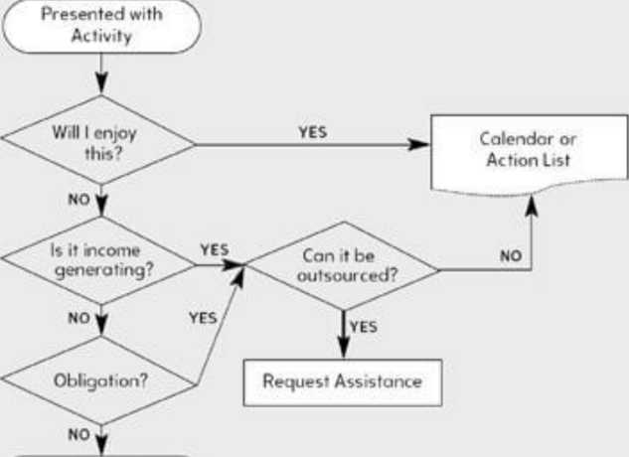
ELIMINATE
Cour ft?* y of th* newt yr tch.com 2007

- Get an assistant—even if you don’t need one.
- Start small but think big. Look at your to-do list—what has been sitting on it the longest? Each time you are interrupted or change tasks, ask, “Could a VA do this?” Examine pain points—what causes you the most frustration and boredom?
- Identify your top five time-consuming non-work tasks and five personal tasks you could assign for sheer fun.
- Keep in sync: scheduling and calendars.
9. Income Autopilot I: Finding the Muse
You now need a product to sell. If you own a service business, this section will help you convert expertise into a downloadable or shippable good to escape the limits of a per-hour-based model.
Step One: Pick an Affordably Reachable Niche Market
- Creating demand is hard. Filling demand is much easier. Don’t create a product, then seek someone to sell it to. Find a market—define your customers—then find ordevelop a product forthem.
- Which social, industry, and professional groups do you belong to, have you belonged to, or do you understand, whether dentists, engineers, rock climbers, recreational cyclists, car restoration aficionados, dancers, or other?
- Which of the groups you identified have their own magazines?
Step Two: Brainstorm (Do Not Invest In) Products
- The Main Benefit Should Be Encapsulated in One Sentence.
- It Should Cost the Customer $50-200.
- I personally aim foran 8-10x markup, which means a $100 product can’t cost me more than $10-12.50.
- It Should Take No More Than 3 to 4 Weeks to Manufacture.
- It Should Be Fully Explainable in a Good Online FAQ.
- Option One: Resell a Product
- Option Two: License a Product
- Option Three: Create a Product
- Information products are low-cost, fast to manufacture, and time-consuming for competitors to duplicate. Consider that the top-selling non-information.
- Income Autopilot II: Testing the Muse
To get an accurate indicator of commercial viability, don’t ask people if they would buy—ask them to buy.
Step Three: Micro-Test Your Products
- Best: Look at the competition and create a more-compelling offer on a basic one-to-three-page website (one to three hours). Use more credibility indicators? (media, academia, associations, and testimonials) Create a better guarantee? Offer better selection? Free or faster shipping?
- Test: Test the offer using short Google Adwords advertising campaigns (three hours to set up and five days of passive observation).
- Divest or Invest: Cut losses with losers and manufacture the winner(s) for
sales rollout.
- Income Autopilot III: MBA—Management by Absence
Once you have a product that sells, it’s time to design a self-correcting business architecture that runs itself.
The diagram should be your rough blueprint for designing a self-sustaining virtual architecture:
- Contract outsourcing companies that specialize in one function vs. freelancers whenever possible so that if someone is fired, quits, or doesn’t perform, you can replace them without interrupting your business. Hire trained groups of people who can provide detailed reporting and replace one another as needed.
- Ensure that all outsourcers are willing to communicate among themselves to solve problems, and give them written permission to make most inexpensive decisions without consulting you first (I started at less than $100 and moved to $400 after two months).
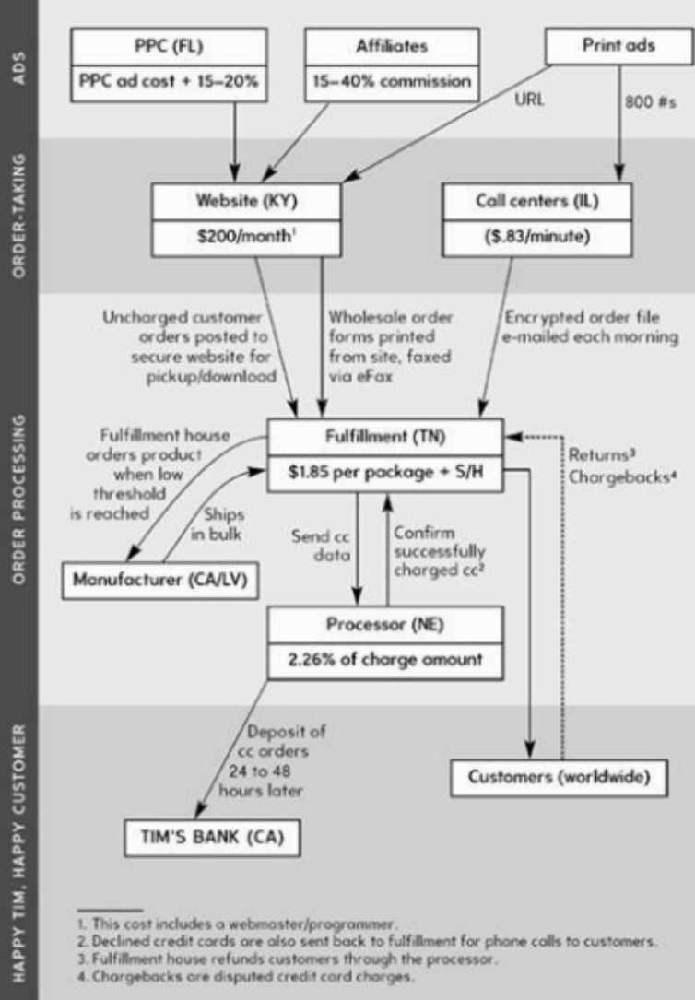

There are good and bad versions of all things, including customers. Good customers and bad customers. Decide now to do business with the former and avoid the latter.
Step IV: L is for Liberation

It is far better for a man to go wrong in freedom than to go right in chains. — Thomas
- Huxley, English biologist; known as ‘‘Darwin’s Bulldog”
- Disappearing Act: Howto Escape the Office
To create the proper leverage to be unshackled, we’ll do two things: demonstrate the business benefit of remote working and make it too expensive or excruciating to refuse a request for it.
- Stepl: Increase Investment. Get the company to invest in some training for you so the cost of losing you is greater.
- Step 2: Prove Increased Output Offsite. Call in sick, work from home and make it a super productive day.
- Step 3: Prepare the Quantifiable Business Benefit. Prepare your results so you can show the quantifiable benefit you gained from working at home.
- Step 4: Propose a Revocable Trial Period. Start with one day a week.
- Step 5: Expand Remote Time. Gradually work up to multiple days at home per week. Then eventually, full-time remote work.
- Beyond Repair: Killing Your Oob
I have quit three jobs and been fired from most of the rest. Getting fired, despite sometimes coming as a surprise and leaving you scrambling to recover, is often a godsend: Someone else makes the decision foryou, and it’s impossible to sit in the wrong job forthe rest of your life.
There are several principal phobias that keep people on sinking ships, and there are simple rebuttals for all of them.
- Quitting is permanent. I have never seen an example where a change of direction wasn’t somehow reversible.
- I won’t be able to pay the bills. Sure you will. First of all, the objective will be to have a new job or source of cash flow before quitting your current job. Problem solved. You can also cut back on unnecessary spending and sell off unused assets to increase cash flow.
- Health insurance and retirement accounts disappear if I quit. Untrue. Upon looking at the facts and exploring options, I realized that I could have identical medical and dental coverage—the same provider and network—for $300-500 per month. To transfer my 401(k) to another company (I chose Fidelity Investments) was even easier: It took less than 30 minutes via phone and cost nothing.
- It will ruin my resume. First, you will get more interviews because you will stand out. Second, interviewers bored in their own jobs will spend the entire meeting
asking how you did it!
- Mini-Retirements: Embracing the Mobile Lifestyle
The mini-retirement—entails relocating to one place for one to six months before going home or moving to another locale. It is the anti-vacation in the most positive sense. Though it can be relaxing, the mini-retirement is not an escape from your life but a reexamination of it—the creation of a blank slate. Following elimination and automation, what would you be escaping from? Rather than seeking to see the world through photo ops between foreign-but-familiar hotels, we aim to experience it at a speed that lets it change us.
True freedom is much more than having enough income and time to do what you want. It is quite possible—actually the rule ratherthan the exception—to have financial and time freedom but still be caught in the throes of the rat race. One cannot be free from the stresses of a speed- and size-obsessed culture until you are free from the materialistic addictions, time-famine mind-set, and comparative impulses that created it in the first place.
- Take an asset and cash-flow snapshot.
- Fear-set a one-year mini-retirement in a dream location in Europe.
- Choose a location foryouractual mini-retirement. Where to start?
- Prepare foryourtrip. Here’s the countdown:
- Three months out - eliminate waste materials.
- Two months out - automate billing with credit cards.
- One month out - redirect mail to a friend, test gotoPC.
- Two weeks out - scan and store digital documents of key info e.g. Credit cards, ID and insurance documents. Downgrade phone plans. Book hostel Accomodation a few days out for cheaper rates.
- One week out - decide on work schedule while you’re away. Put other belongings into storage.
- Two days out - store car, add thing to tank to store fuel, disconnect battery leads.
- When you arrive - sort health insurances, make booking to view apartments (one month only), go on bus/bike tours of the city.
- Filling the Void: Adding Life After Subtracting Work
But This Is What I Always Wanted! How Can I Be Bored?!
Don’t freak out and fuel the fire. This is normal among all high-performers who downshift after working hard for a long time. The smarter and more goal-oriented you are, the tougherthese growing pains will be. Learningto replace the perception of time famine with appreciation of time abundance is like going from triple espressos to decaf.
In the process of searching for a new focus, it is almost inevitable that the “big” questions will creep in. There is pressure from pseudo-philosophers everywhere to cast aside the impertinent and answer the eternal. Two popular examples are “What is the meaning of life?" and “What is the point of it all?
Before spending time on a stress-inducing question, big or otherwise, ensure that the answer is “yes” to the following two questions:
- Have I decided on a single meaning for each term in this question?
- Can an answerto this question be acted upon to improve things?
If you can’t define it or act upon it, forget it. If you take just this point from this book, it will put you in the top 1% of performers in the world and keep most philosophical distress out of your life.
To live is to learn. I see no other option.
Though you can upgrade your brain domestically, traveling and relocating provides unique conditions that make progress much faster. I rarely travel somewhere without decidingfirst how I’ll obsess on a specific skill. I tend to focus on language acquisition and one kinesthetic skill, sometimes finding the latter after landing overseas. The most successful serial vagabonds tend to blend the mental and the physical.
- The Top 13 New Rich Mistakes
- Losing sight of dreams and falling into work for work’s sake (W4W).
- Micromanaging and e-mailingtofill time.
- Handling problems your outsourcers or co-workers can handle.
- Helping outsourcers orco-workers with the same problem more than once, or with noncrisis problems.
- Chasing customers, particularly unqualified or international prospects, when you have sufficient cash flow to finance your nonfinancial pursuits.
- Answering e-mail that will not result in a sale or that can be answered by a FAQ orauto-responder.
- Working where you live, sleep, orshould relax.

- Not performing a thorough 80/20 analysis every two to four weeks for your business and personal life.
- Strivingforendless perfection ratherthan great or simply good enough, whether in your personal or professional life.
- Blowing minutiae and small problems out of proportion as an excuse to work.
- Making non-time-sensitive issues urgent in orderto justify work.
- Viewing one product, job, or project as the end-all and be-all of your existence.
- Ignoring the social rewards of life.

